**Assignment-1**

1. What happens when you login a non-existent users or username?

**Ans-** There are two types of users in Linux System and both are unique.

1. Root User/Super User – Access to all files in the system.
2. Normal User – Limited Access.

To login into any Linux system, we need to create the user in that system and we need the login credentials (Correct Username and Password). So, if we want to log in as a user which does not exist in our system it will throw below error.

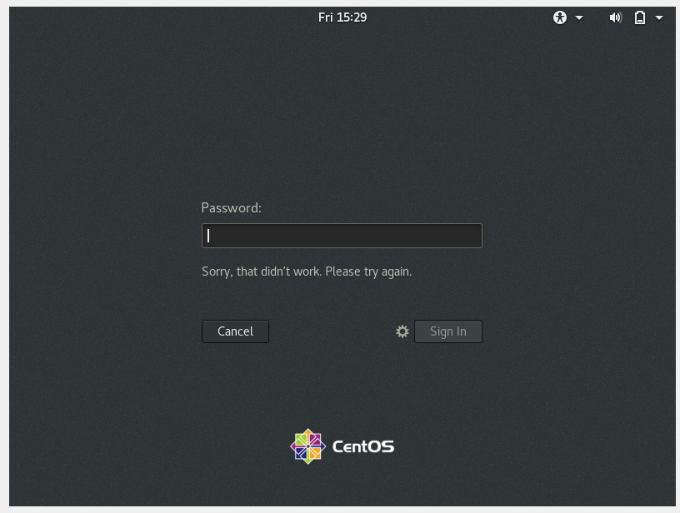

**Assignment-2**

1. Login into your account and then change password?
2. Change your password into **IneuR0n#42** and hit the **Enter** key

**Ans**- To change the existing password the command is **passwd** then it will prompt to enter new password and then re-enter the password as **IneuROn#42** is matching with Linux password policy.

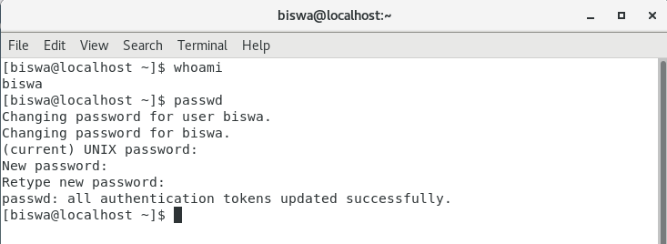

1. Try again to change password but use like password ***1234*** or ***abcd***

**Ans**- It is recommended to use a strong password that should have 8 or greater than 8 characters.

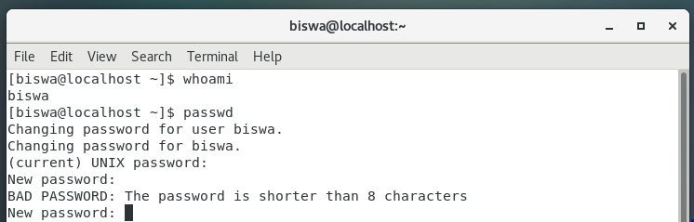

1. Try again to change password but now don’t use any password just hit **Enter** key

**Ans-** As we didn’t provide any password the centos system throws Authentication token manipulation error.

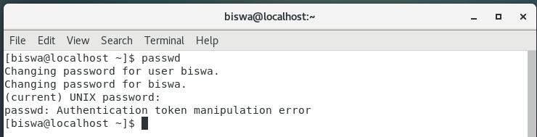

**Assignment-3**

1. Enter the command **cd /** and then **ls** and then hit the “**Enter”** key. Take screenshot and explain what output we got?

**Ans-**

1. Here “CD” denotes the “change directory” and “/” denotes the “root directory”.
2. The “ls” command shows the list of contents of the directory.
3. If we provide the input as “cd /” in the terminal it will change the current directory to the root directory and by entering ls command it will show the list of directories available in root.

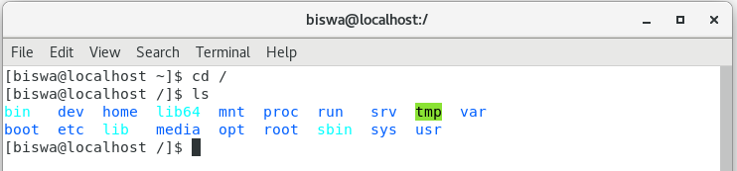

1. Enter the command now cd /home and then hit Enter key. Do ls, provide screenshot and explain what is /home directory used for?

**Ans-** home directory is a directory for a particular user of the system. In-Home directory users’ personal files are stored.

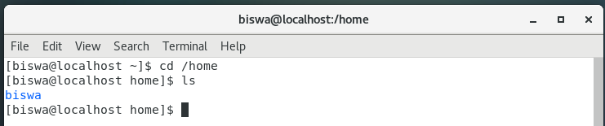

1. Enter **cd ..** and hit **Enter** key [ Note: here we have space after cd then use double dot]. Check what happen and give screenshot?

**Ans-** cd .. command is used to move to the parent directory of current directory or we can say one level up from the current directory.

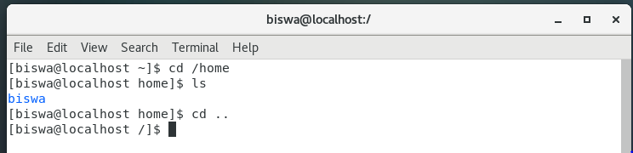

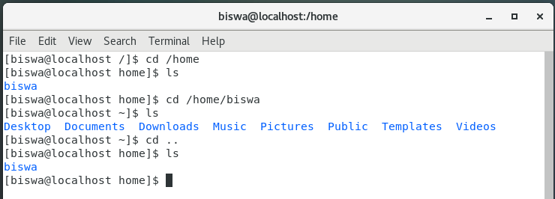

1. Now enter **cd /var/www/html** and then type **cd** and hit **Enter** key. Explain what happen and give screenshot?

**Ans-**

1. Initially I don’t have any www directory in var, So I have created the www/html using sudo.
2. After successfully created both directory I pushed cd command followed by enter key which redirected to home directory.

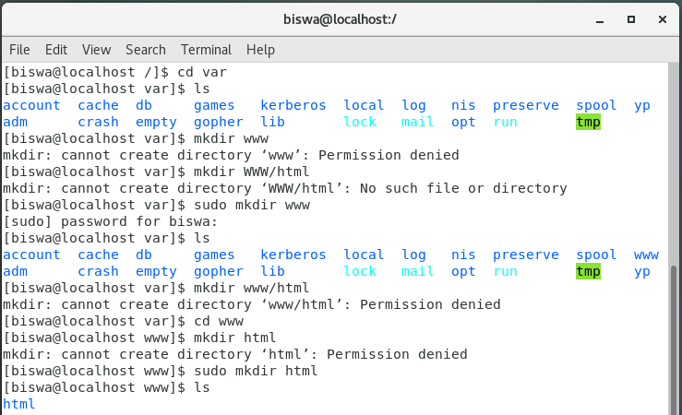

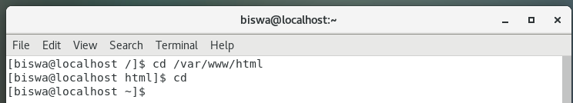

1. Now type **cd /root** and then hit **Enter** key. Do **ls**, check any output we have on screen if yes then take screenshot?

**Ans-** Initially I was logged in as a normal user so I am unable to change to the root directory. Using sudo su, followed by the root password I successfully switched to the root user.

Secondly, I have pushed the cd /root and then the ls command in to the terminal and below is the output.

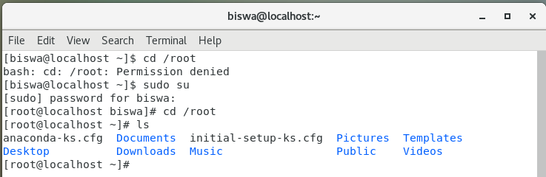

**Assignment-4**

Working with File Listing

1. Go to **cd /etc** and type **ls**. Take screenshot and explain what files you have seeing? Take screenshot and explain what different output you found compare to previous command you used?

**Ans-** etc directory is having multiple configuration files.

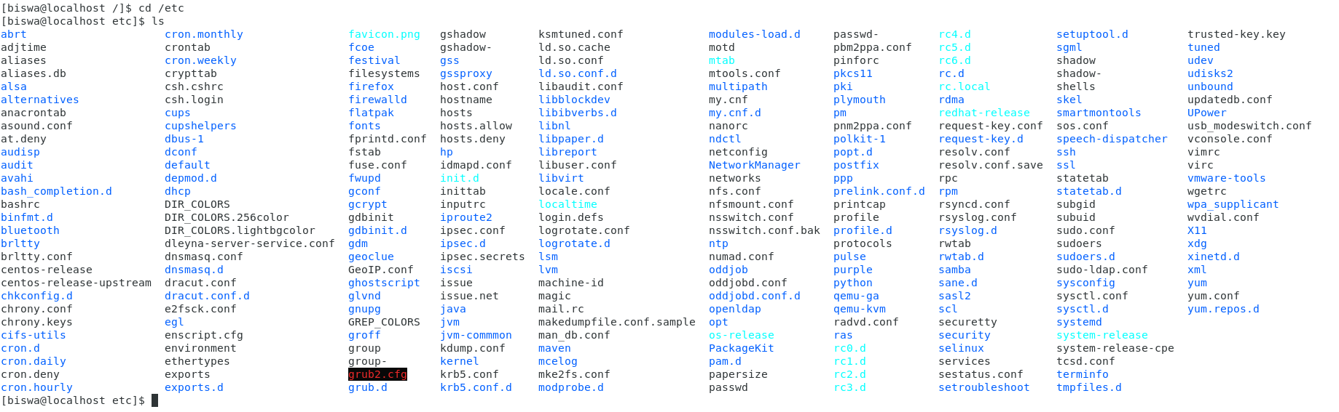

1. Then type **ls -al** and hit **Enter** key. Take screenshot and explain what new file or directory you found?

**Ans-** ls -al command displays all list of hidden files, file Permissions, file size, last modification etc.

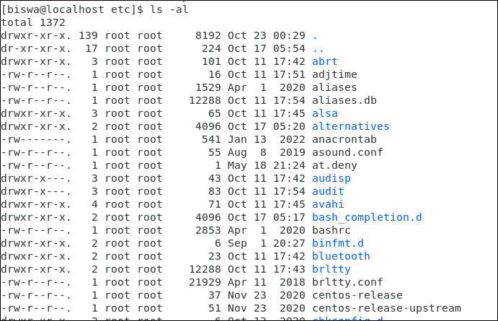

1. Then use ls -i and hit Enter key. Now see what different output its shows and take screenshot?

**Ans-** ls -i display the inode number beside each file or directory. Linux OS allocates an index node (inode) to each file/ Directory. Inodes are uniquely defined for every file and directory and they store the metadata.

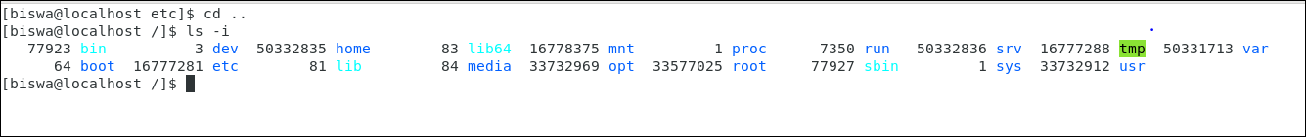

**Assignment-5**

Know where you are and where you working

1. Open terminal after restart the Linux . Check which location you working, type **pwd** and take screenshot

Ans- 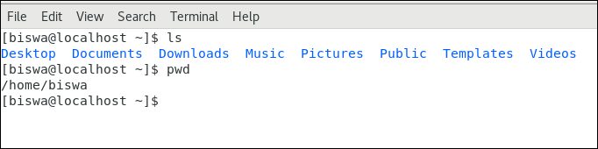

1. Now use **cd /var** and hit **Enter** key. Do **ls,** and see what output comes, give screenshot?

Ans- 